**Pre-Requisites**

|  |  |
| --- | --- |
| **Project Title** | Smart Farmer – IoT Enabled Smart Farming Application |
| **Team ID** | PNT2022TMID04463 |
| **Content** | **IBM Cloud Service** |

Type IBM Cloud in Google and click on the first link.

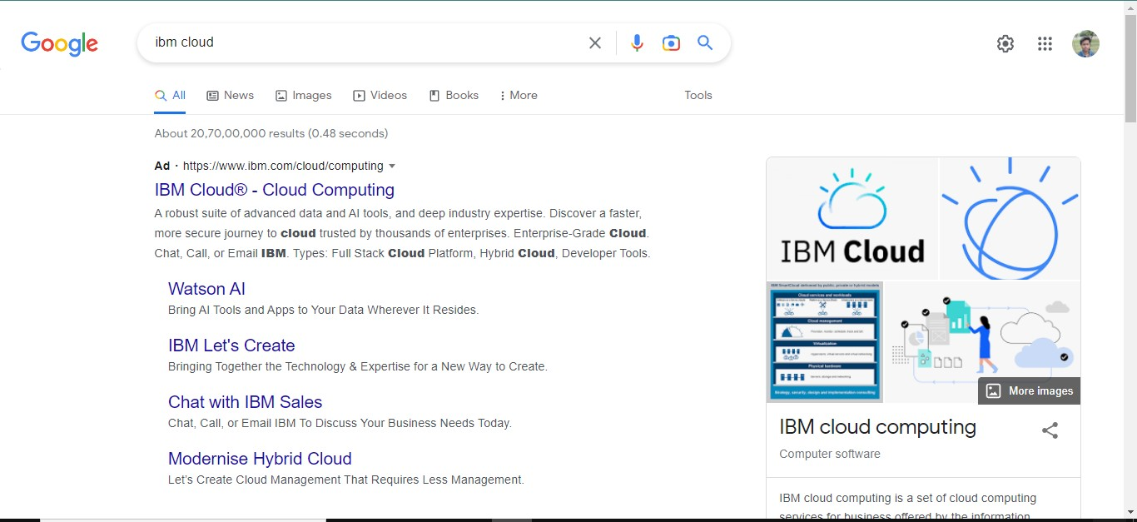

Click on create IBM Cloud Account Now and enter the details.

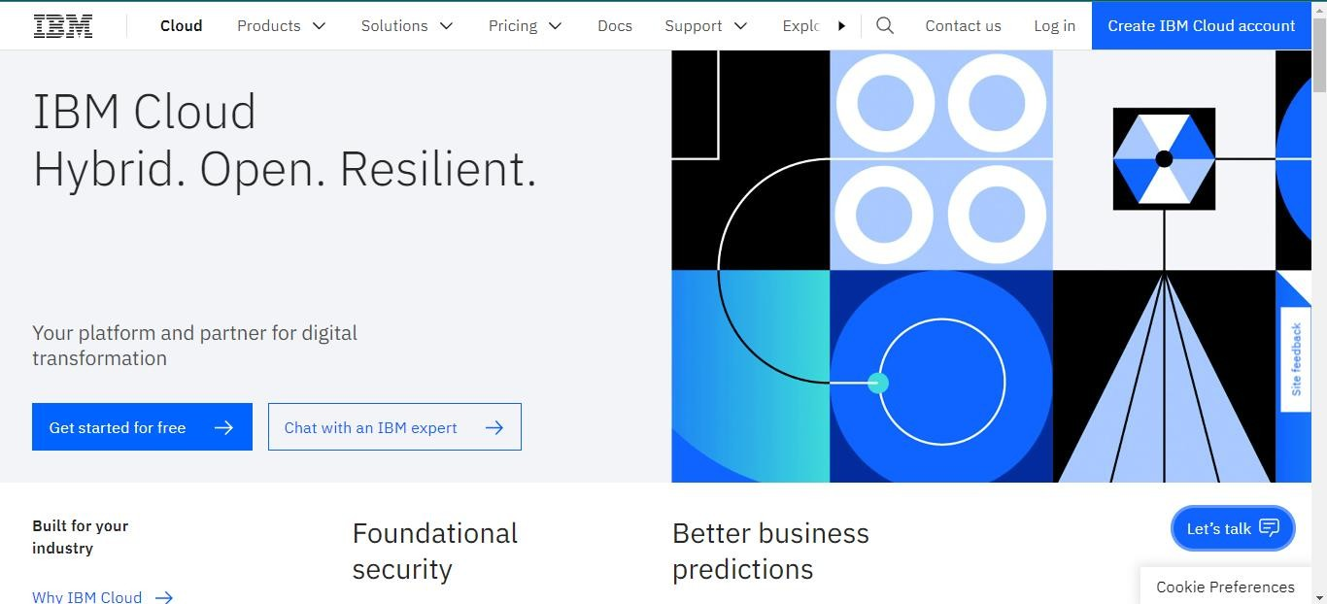

You will get the email with your password. Type your mail Id and the password then click on the login button.

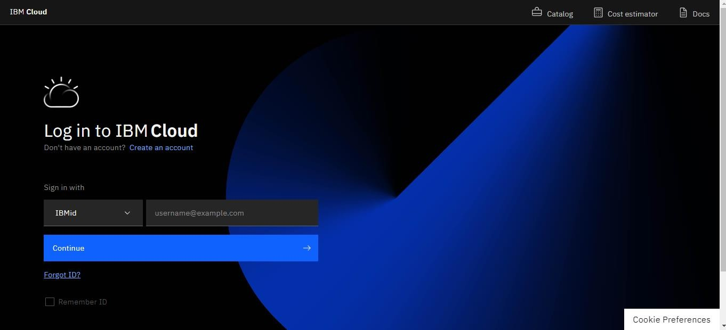

Now you are in Dashboard

From Dashboard you can now navigate IBM IoT Platform by searching in search bar.

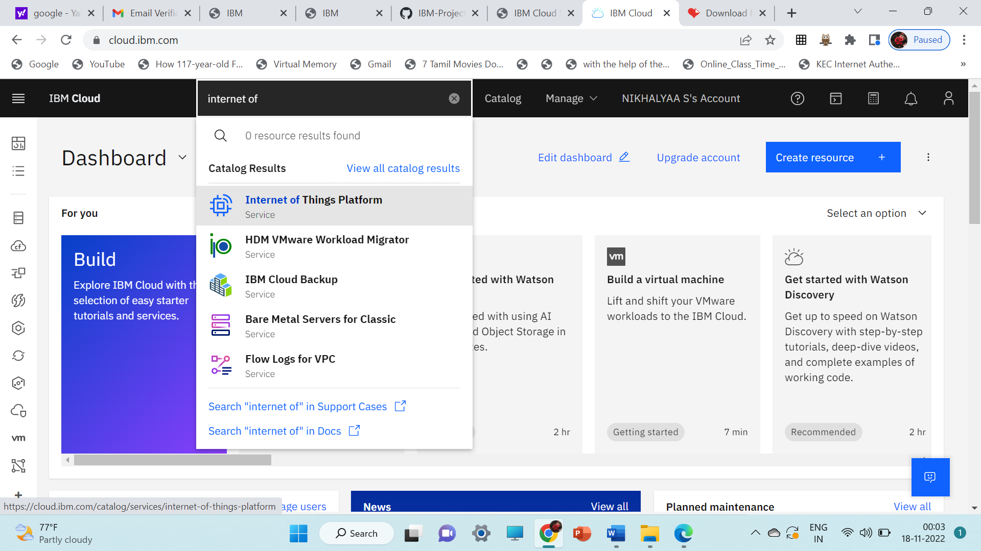

Click on Internet of Things Platform and then create your platform by clicking create. Note:- Change your location to London.

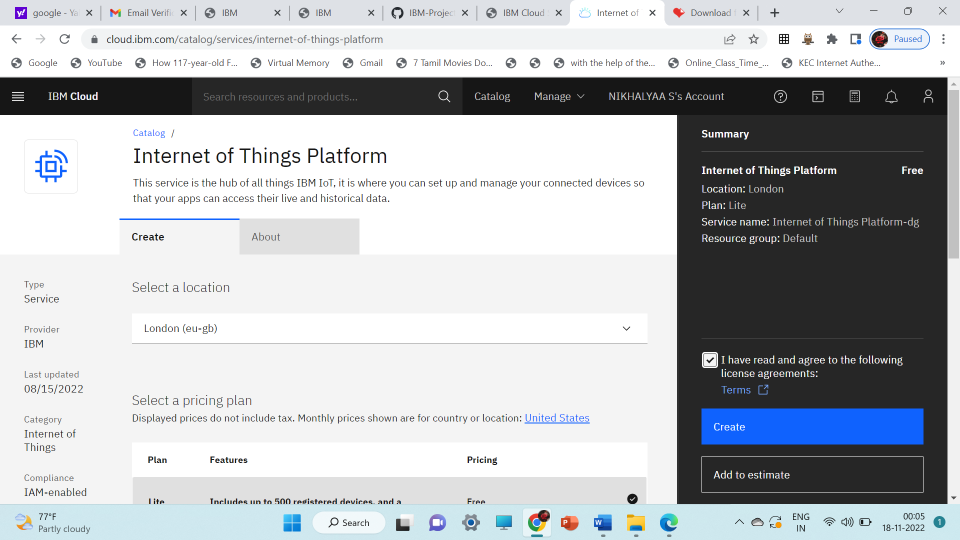

Now Click Launch to launch

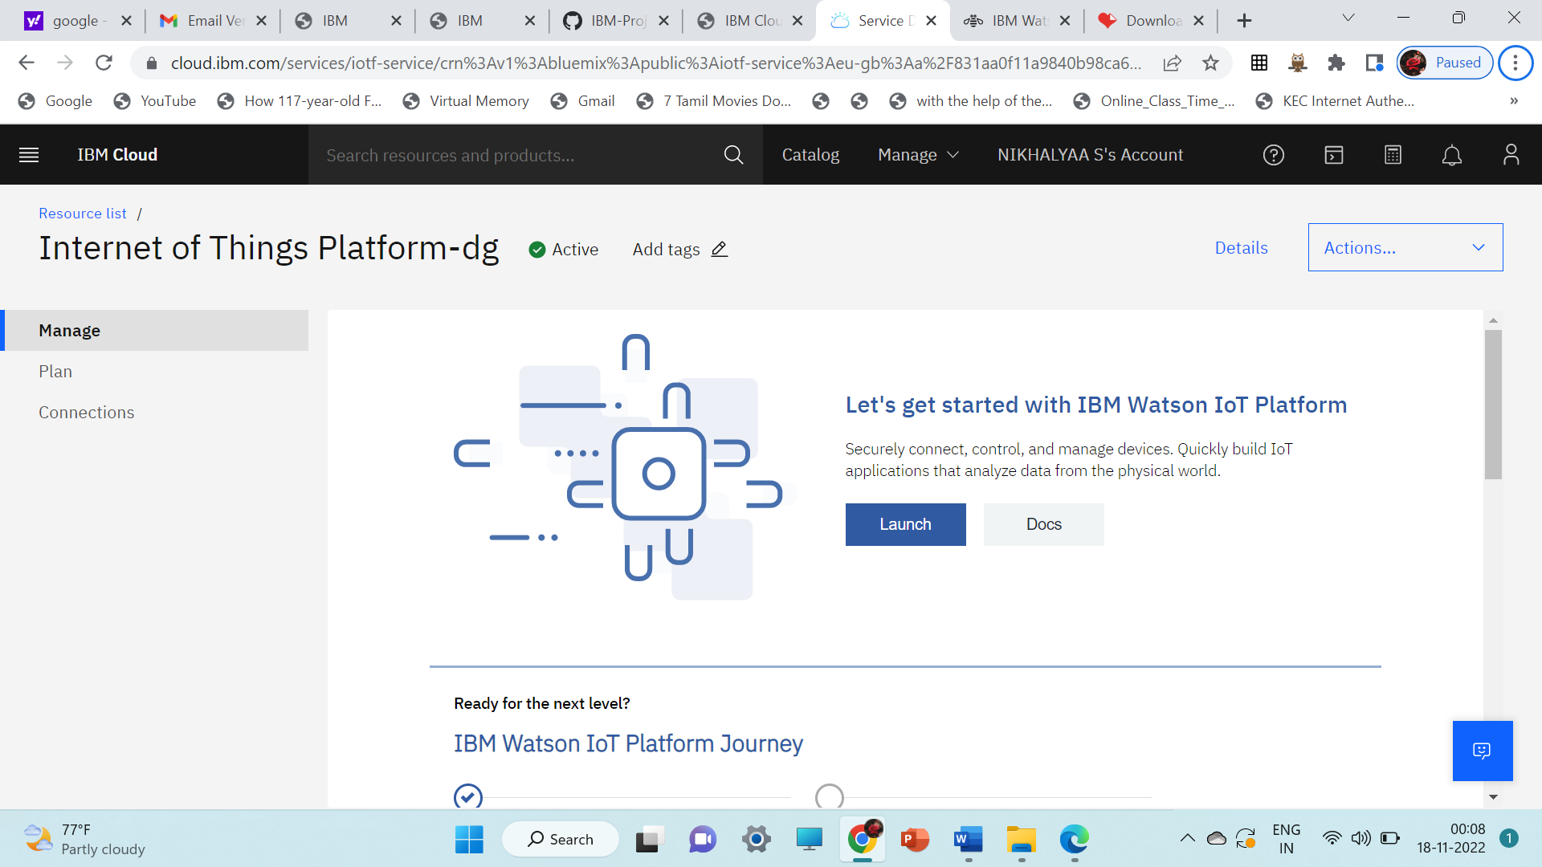

STEP 7: IBM Watson IOT platform

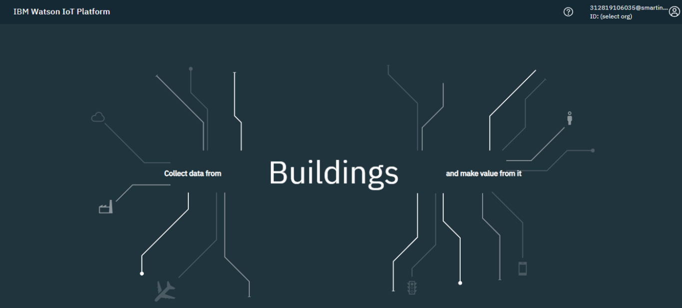

STEP 8:

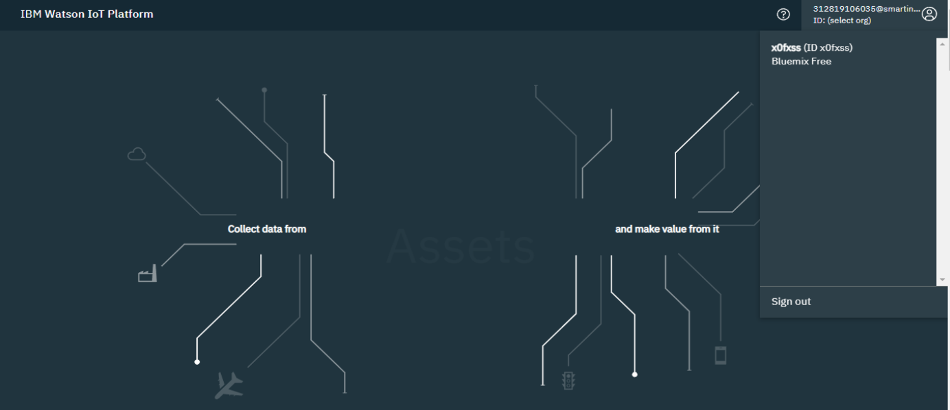

STEP 9:

Now you can create your device by Devices>Add Device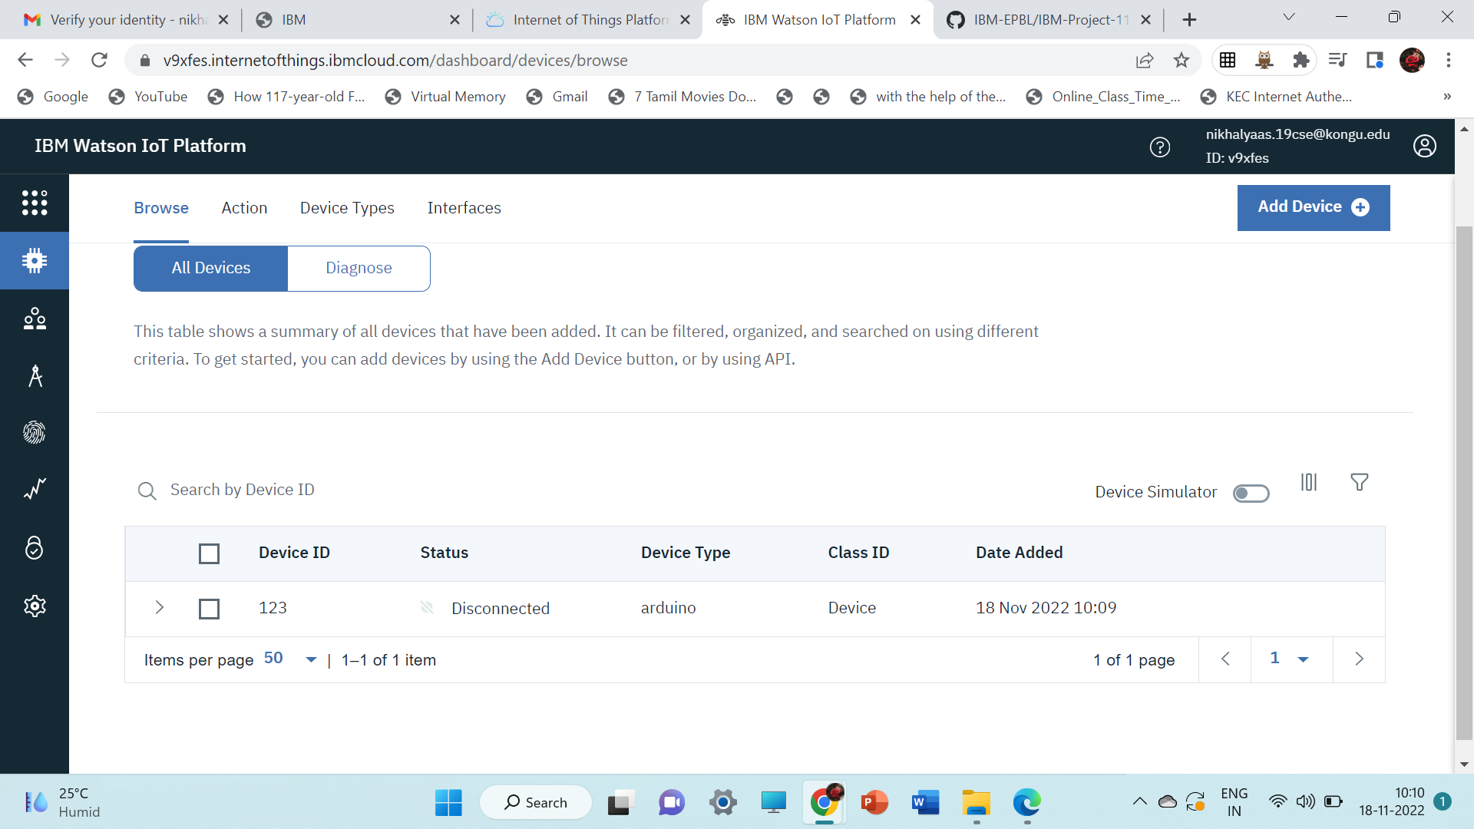

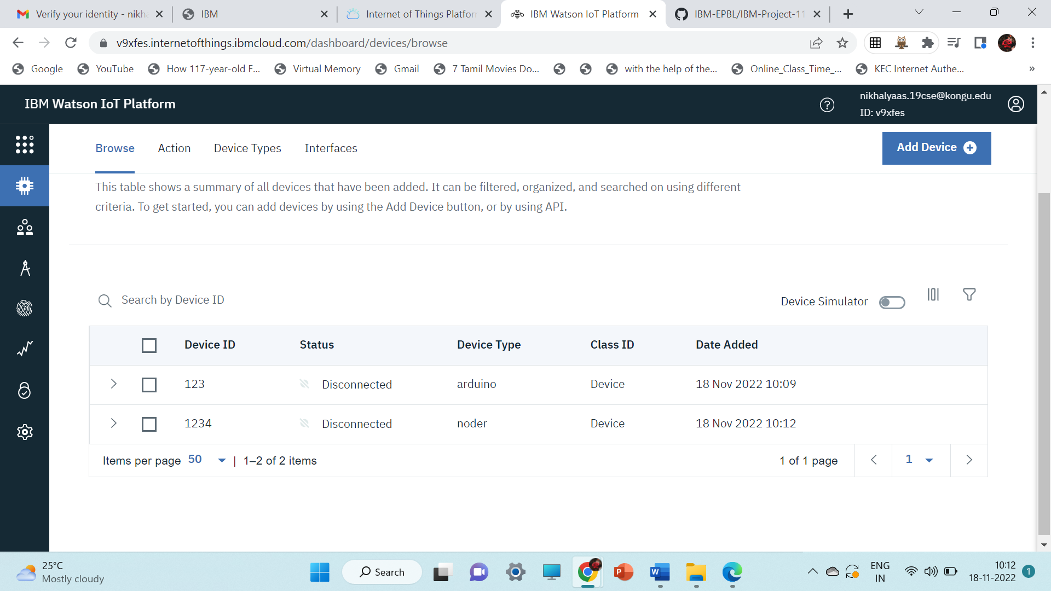

STEP 10: You can create your API Key by Apps > Generate API Key. While creation choose Application as Standard Application

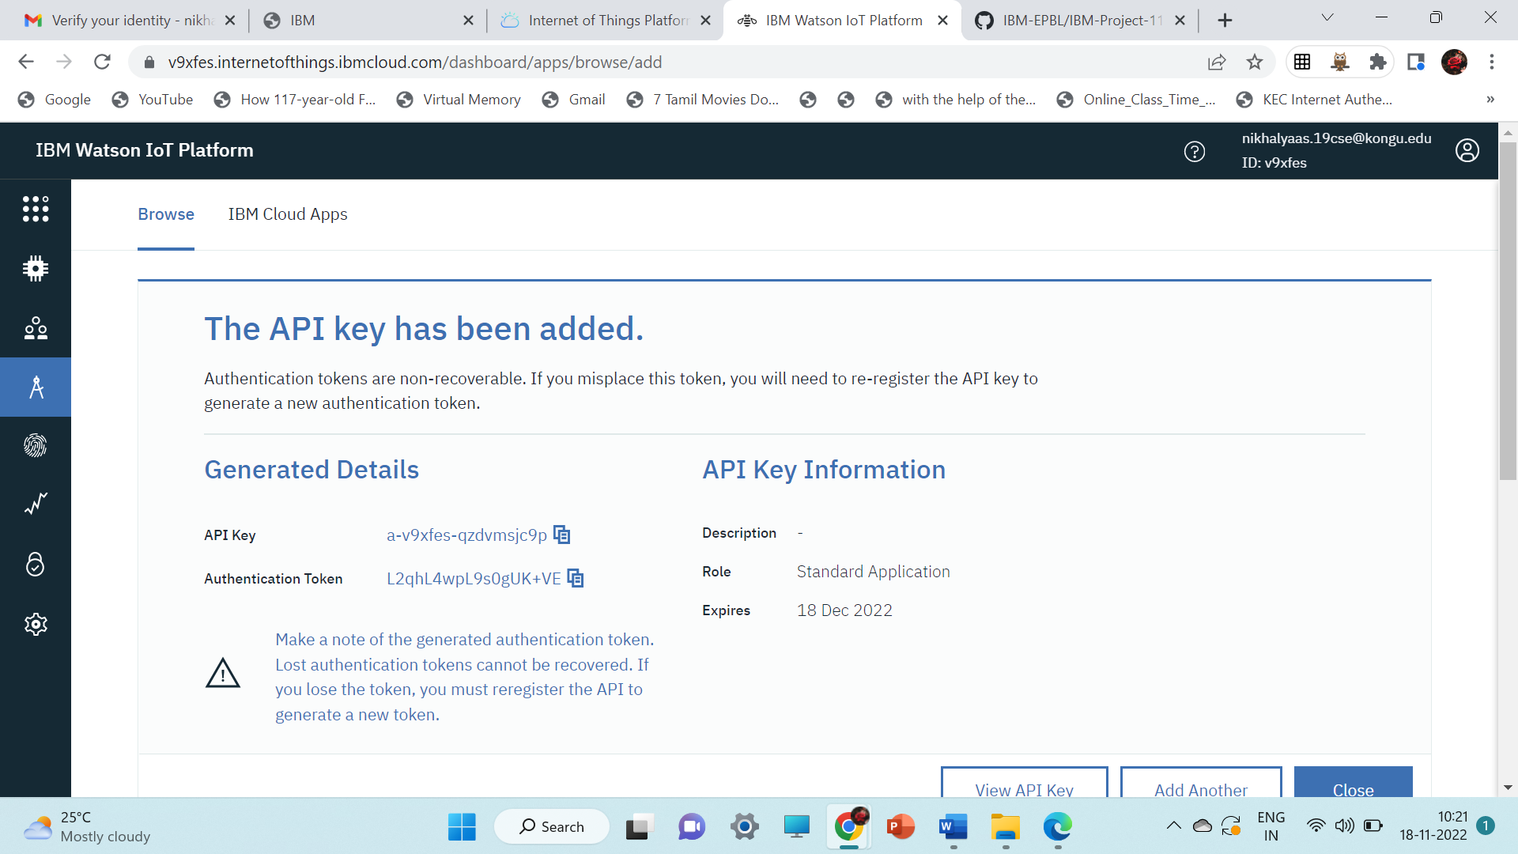

You can create your own card by clicking by Boards > Create New Board.

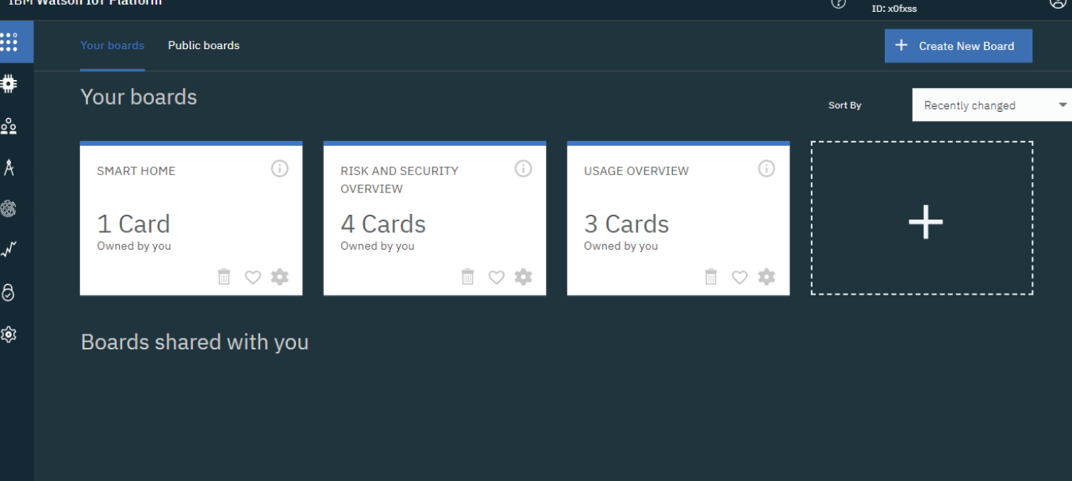

By clicking the created card, where you can represent the data in different forms. If you don’t have card you can create it by clicking add new card

